OVLP Academic Year 2025-26
Duration: March 16 - 20, 2026 |  |  | Grade: Pre-Nursery |  |  | Subjects: All
Term III |  |  |  | Week: 3
 | English | Urdu |  |  | Math |  | IT | HCD
Links | class story  Tree:  https://drive.google.com/file/d/1YPejH9GCHm0rIpelgWYzrax3qNHjepIF/view?usp=sharing  The Honest Elephant:  https://drive.google.com/file/d/1lwAwKqlnQvW-hFTRBqN4f_tHvo_02jVv/view?usp=sharing  Letter s  https://drive.google.com/file/d/1IACTdeGUYCCcnI03K7Rnjw_ZzRydPrHp/view?usp=share_link  Reading Letter s  https://drive.google.com/file/d/1_NuFcFhvHB-x8_kt7txATyrmQqa9tJ0T/view?usp=sharing | class story  Murghi or chiriya  https://drive.google.com/file/d/1l1Gdko6TYpm5cb6e8JHlenTX2PK9_s5h/view?usp=sharing  Bhalu ka bacha  https://drive.google.com/file/d/1ncUv2pL3RmwAOLrY5lHQ84rCgscjfDzj/view?usp=sharing  Ont or Saya  https://drive.google.com/file/d/1kickcOMQo0xpV-bJFEhDATb68gkuEENC/view?usp=sharing  Harf seen.  https://drive.google.com/file/d/1MIrXKfNqh5muzfAk0FXota_k4Ffg_Llc/view?usp=share_link  Reading Harf seen.  https://drive.google.com/file/d/15n-fCUf6K4bmzUGQaKolnjE9m0bMMXLc/view?usp=sharing |  |  | Number 18.  https://drive.google.com/file/d/1YESzjXilRyaZzIZuP-X8orAKPyRdCoMm/view?usp=sharing  Reading Number 18.  https://drive.google.com/file/d/1nv6u6wlHUzwY4IcfvtKbl6nTjka6nzgq/view?usp=sharing |  | Week 3 OVLP Grade Pre-Nursery IT Term 3.mp4 | P.N TIIISRP3
Day 1  C.W | - Writing “s”.  - Draw a picture with “s”. (sun, star or snake)  Note book pg. # 41 | 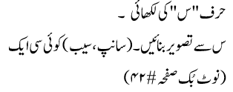 |  |  | Recognition of number 18 |  |  | Pupils will learn about Respecting People/ Fruits
Home work | - Writing “s”.  - Draw a picture with “s”. (sun, star or snake)  Note book pg. # 42 | ____________ |  |  | _____________ |  |  | -------
Day 2  C.W | Reading letter s | 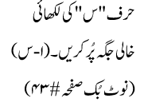 |  |  | - Writing number 18.  - Count and write” (16, 17 and 18)  - Note book pg. # 34 |  |  | Pupils will learn about the food of the week is “Cheese”
Home work |  | 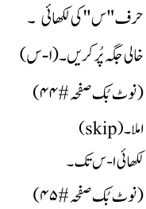 |  |  | _____________ |  |  | --------
Day 3  C.W | - Writing “s”.(skip)  - What comes next?  - n __, q__, j __, r__  - Note book pg. # 43  - Write a-s.  - Match the same letters (q – s).  Note book pg. # 44 | 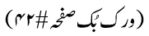 |  |  | - Writing number 18.  - Circle the correct number. (9 – 17)  - Note book pg. # 35 |  |  | Pupils will be playing the game Fruit basket  Oral questions and answers  Q 1: On which day do we celebrate Pakistan’s Independence Day? Ans: We celebrate Pakistan’s Independence Day on 14th August.  Q 1: How many Fast do we have in Ramadan? Ans: There are 30 Fast in Ramadan.  Q 1: Tell the names of 5 fruits. Apple, Banana, Orange, Grapes and Watermelon.
Home work | _____________ | 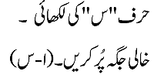 |  |  | - Writing number 18.  - Count and write” (16, 17 and 18)  Note book pg. # 36 & 37(Write counting 0-18) |  |  | -----------
Day 4  C.W | Revision ( Online Class) |  |  |  |  |  |  | Revision ( Online Class)
Home work |  | _____________ |  |  |  |  |  | --------------
Day 5  C.W | Eid Holiday |  |  |  |  |  |  | Holiday
Home work |  |  |  |  |  |  |  | -------------

